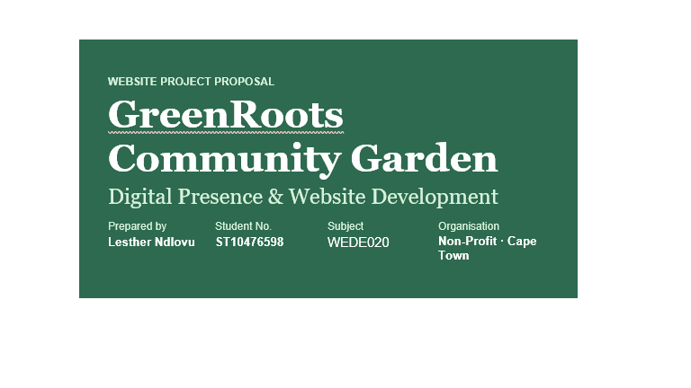

Section 01
Organisation Overview
GreenRoots community garden is a registered non-praprofit that was founded in 2015 in the Woodstock suburb of Cape Town. The organisation has taken two abandoned plots and developed community gardens that now benefit due to a membership of over 300 people. Its mission is to build community links, promote sustainable living and give everybody fair access to fresh produce. The purpose audience consists of local residents, schools, corporates (CSR), and donors who support urban agriculture.
Section 02
Website Goals & Objectives
The website will serve as GreenRoots' digital hub — driving membership registrations, online donations, and event attendance. Key goals include:

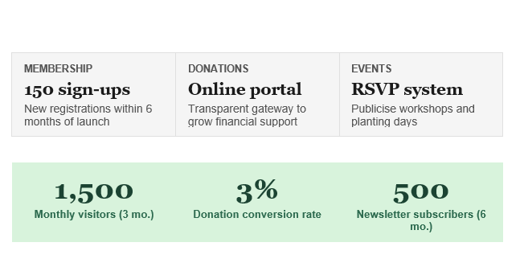

Section 03
Current Website Analysis
GreenRoots website has been offline since 2021 and has only a basic placeholder page with a contact email address. The website suffers from the following shortcomings: Lack of mobile responsiveness, outdated content, absence of a donations function and poor search engine optimization to the extent that it cannot be found in a Google index. The remodelling agenda comprises of a mobile first remodelling and a complete, well planned search engine optimization plan that includes a payment gateway.

Section 04
Proposed Features & Functionality
The new website will deliver a comprehensive digital experience across IMPORTANT pages:

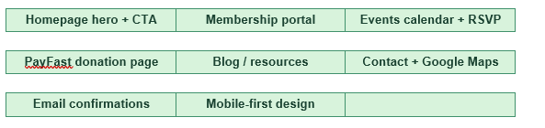

Section 05
Design & User Experience
The design contains principles of growth and sustainability. Pairing typographical decisions of Georgia headlines and Arial body fonts.

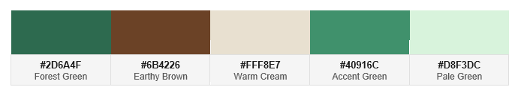

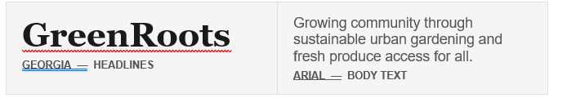

HOMEPAGE WIREFRAME — LIVE PREVIEW

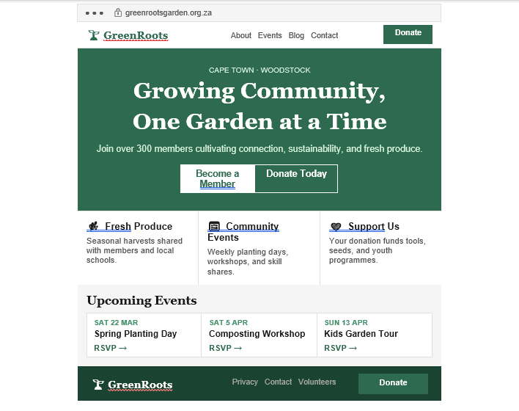

Section 06
Technical Requirements
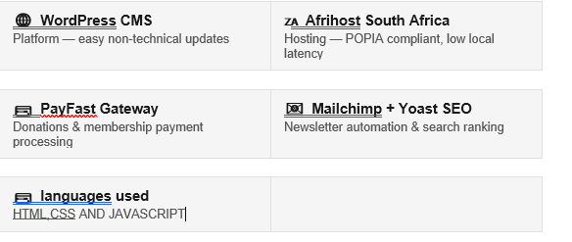

Section 07
Project Timeline

WEEKS 1–2
Discovery & planning
WEEKS 3–4
Design mockups & brand refinement
WEEKS 5–8
Development & integrations (PayFast, Mailchimp, Events Calendar)
WEEKS 9–10
Content population & photography
WEEKS 11–12
Testing, accessibility audit & launch

Section 08
Budget Estimate

LINE ITEM | AMOUNT
Hosting & Domain (Afrihost) | R 1,950
Theme & Plugins | R 2,100
Development (80 hrs @ R 300/hr) | R 24,000
Content & Photography | R 5,500
Contingency (10%) | R 3,355
Total Estimated Budget | R 36,905

Section 09
References

Afrihost. (2024). Shared web hosting plans. Retrieved from https://www.afrihost.com/
PayFast. (2024). PayFast merchant documentation. Retrieved from https://developers.payfast.co.za/
Web Content Accessibility Guidelines (WCAG) 2.1. (2018). W3C. Retrieved from https://www.w3.org/TR/WCAG21/
WordPress. (2024). WordPress for nonprofits. Retrieved from https://wordpress.org/
Yoast. (2024). SEO for nonprofits: Getting started guide. Retrieved from https://yoast.com/

